Department of Mathematics

School of Advanced Sciences

MAT 1011 – Calculus for Engineers (MATLAB)

Experiment 2–B

Laplace transforms, Inverse Laplace transform

Prepared by: Bimal parajuli

Registration Number: 20BDS0405

**Question 1(i)**

**Write the MATLAB code to find the Laplace transform of f(t) **

CODES:

clear

close all

clc

syms t

f=input('Enter the function');

F=laplace(f);

disp('The laplace transform of the given function is')

disp(F)

INPUT:

Enter the function

1+2*sqrt(t)+3/sqrt(t)

OUTPUT:

The laplace transform of the given function is  
1/s + (3*pi^(1/2))/s^(1/2) + pi^(1/2)/s^(3/2)

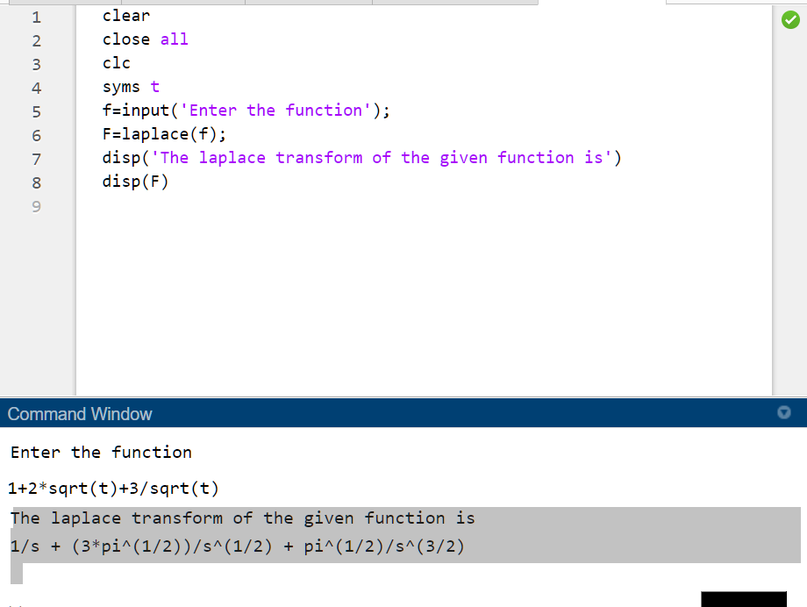

**Question 1(ii)**

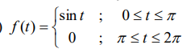**Write the MATLAB code to find the Laplace transform of f(t)**

**Code :**

clear

close all

clc

syms t

f=input('Enter the function');

F=laplace(f);

disp('The laplace transform of the given function is')

disp(F)

**INPUT:**

Enter the function

sin(t)*(heaviside(t)-heaviside(t-pi))+0*(heaviside(t-pi)-heaviside(t-2*pi))

**OUTPUT:**

The laplace transform of the given function is  
(exp(pi*s) + 1)/(exp(pi*s) + s^2*exp(pi*s))

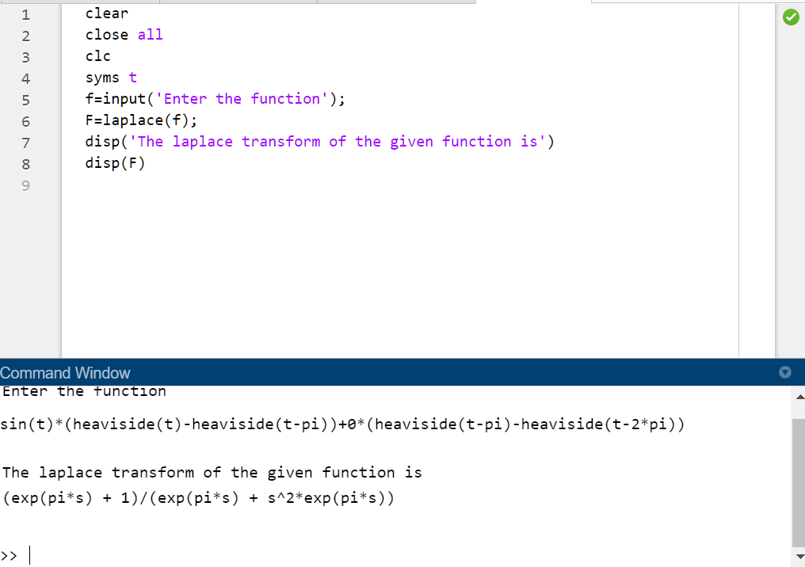

**Question 1(iii):**

**Write the MATLAB code to find the Laplace transform of $f\left(t\right)=\sin^{3}{t}$**

Codes:

clear

close all

clc

syms t

f=input('Enter the function');

F=laplace(f);

disp('The laplace transform of the given function is')

disp(F)

INPUT:

Enter the function

(sin(t))^3

OUTPUT:

The laplace transform of the given function is  
6/((s^2 + 1)*(s^2 + 9))

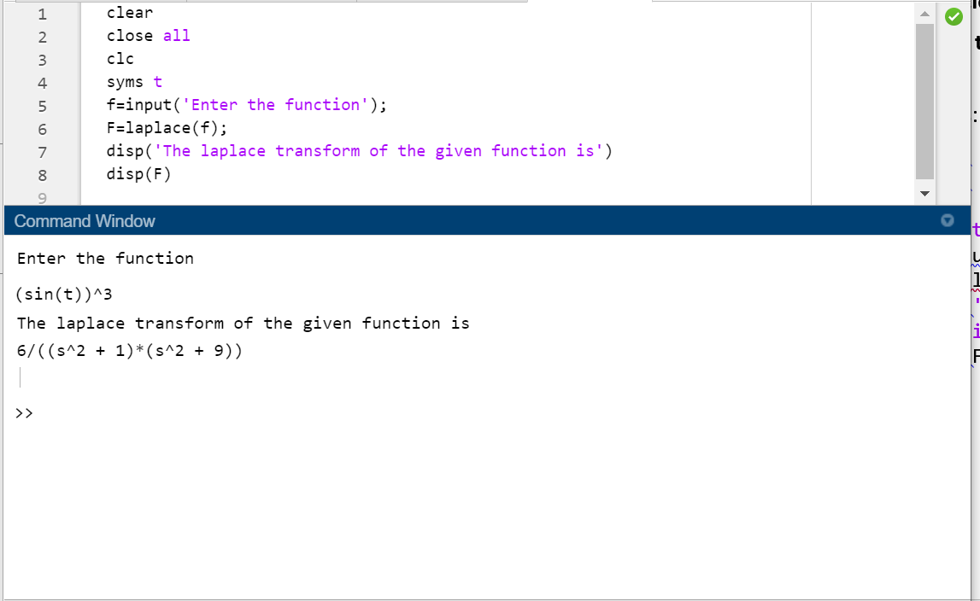

**Question 1(IV):**

**Write the MATLAB code to find the Laplace transform of**

$$f\left(x\right)=sin\left(2t\right).sin(3t)$$

Codes:

clear

close all

clc

syms t

f=input('Enter the function');

F=laplace(f);exp()

disp('The laplace transform of the sin(2t)given function is')

disp(F)

**INPUT:**

Enter the function

sin(2*t)*sin(3*t)

**OUTPUT:**

**The laplace transform of the given function is  
s/(2*(s^2 + 1)) - s/(2*(s^2 + 25))**

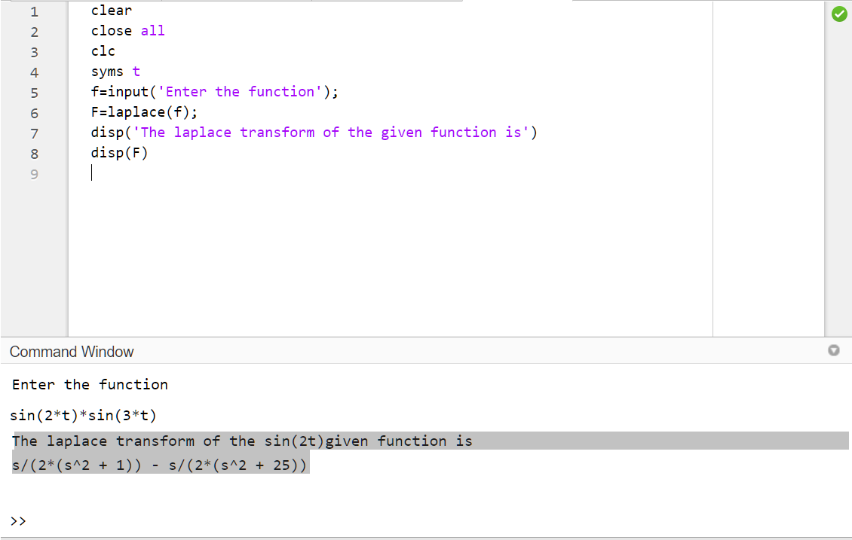

**Question 1(v):**

**Write the MATLAB code to find the Laplace transform of**

$$f\left(t\right)=e^{-t}\sin^{2}t$$

Codes:

clear

close all

clc

syms t

f=input('Enter the function');

F=laplace(f);

disp('The laplace transform of the given function is')

disp(F)

Input:

Enter the function

exp(-t)*(sin(t))^2

Output:

The laplace transform of the given function is  
1/(2*(s + 1)) - (s + 1)/(2*((s + 1)^2 + 4))  
 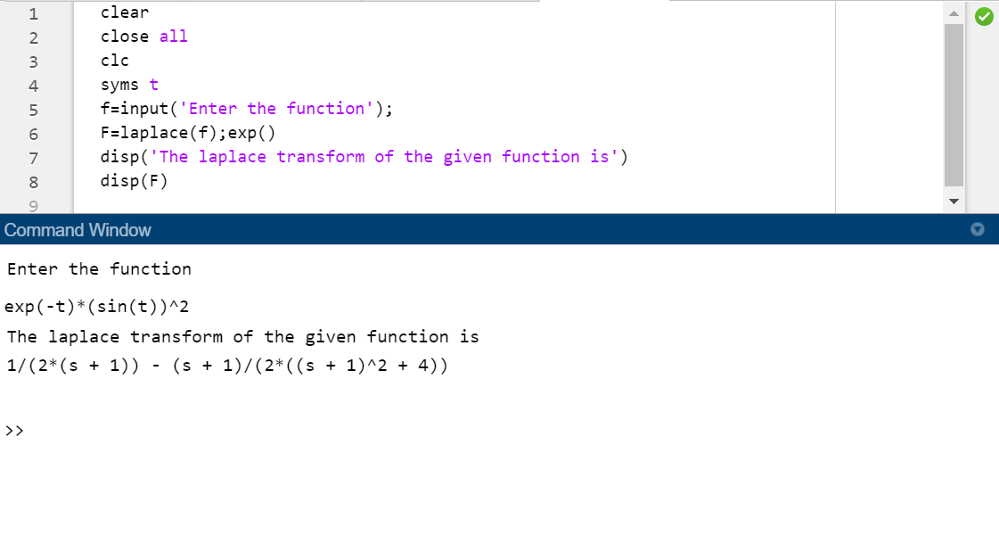

**Question 1 (vi):**

**Write the MATLAB code to find the Laplace transform of**

$$f\left(t\right)=\frac{cos\left(2t\right)-cos(3t)}{t}$$

Codes:

clear

close all

clc

syms t

f=input('Enter the function');

F=laplace(f);

disp('The laplace transform of the given function is')

disp(F)

**INPUT:**

Enter the function

(cos(2*t)-cos(3*t))/t

**OUTPUT:**

The Laplace transform of the given function is  
log(9/s^2 + 1)/2 - log(4/s^2 + 1)/2

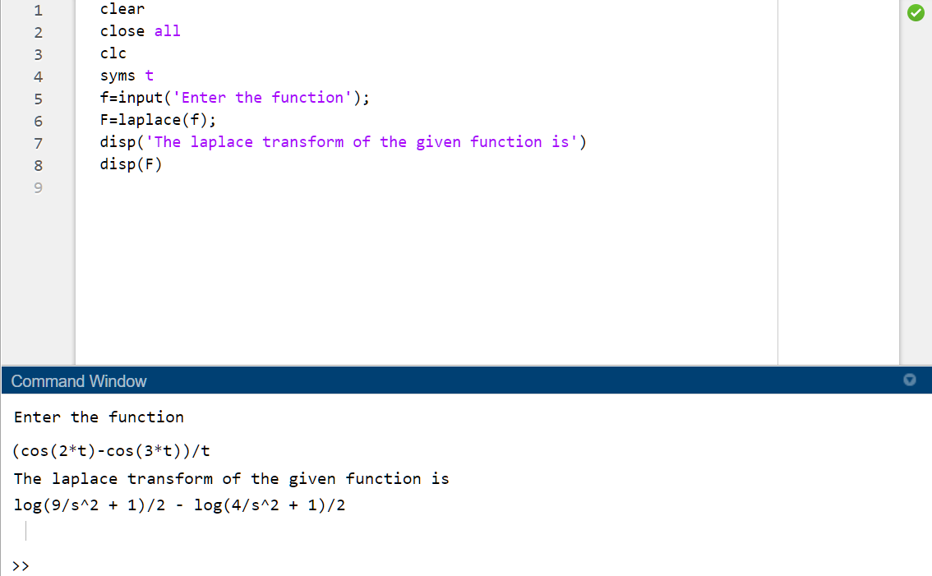

**Question number 2(i)**

**Find the inverse Laplace transforms of the following functions: $f\left(x\right)=\frac{6}{s^{2}+2s-8}$**

**CODE:**

clear

close all

clc

syms s a

F=input('Enter the function of s to calculate its laplace inverse:');

f=ilaplace(F);

disp('The inverse laplace of the given function is :')

disp(f);

**INPUT:**

Enter the function of s to calculate its laplace inverse:

6/(s^2+2*s-8)

**OUTPUT:**

The inverse laplace of the given function is :  
exp(2*t) - exp(-4*t)

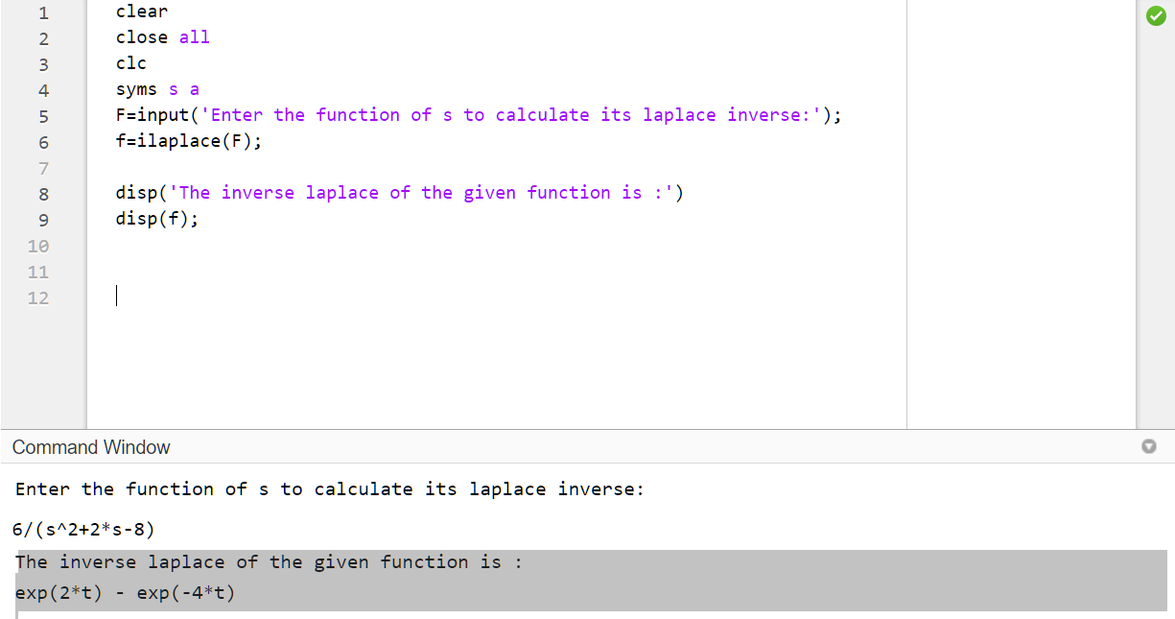

**Question number 2(ii)**

**Find the inverse Laplace transforms of the following functions: $f\left(x\right)=\frac{4s+5}{{\left(s-1\right)}^{2}(s+2)}$**

**Codes:**

clear

close all

clc

syms s a

F=input('Enter the function of s to calculate its laplace inverse:');

f=ilaplace(F);

disp('The inverse laplace of the given function is :')

disp(f);

**INPUT:**

Enter the function of s to calculate its laplace inverse:

(4*s+5)/(((s-1)^2)*(s+2))

**OUTPUT:**

The inverse laplace of the given function is :  
exp(t)/3 - exp(-2*t)/3 + 3*t*exp(t)

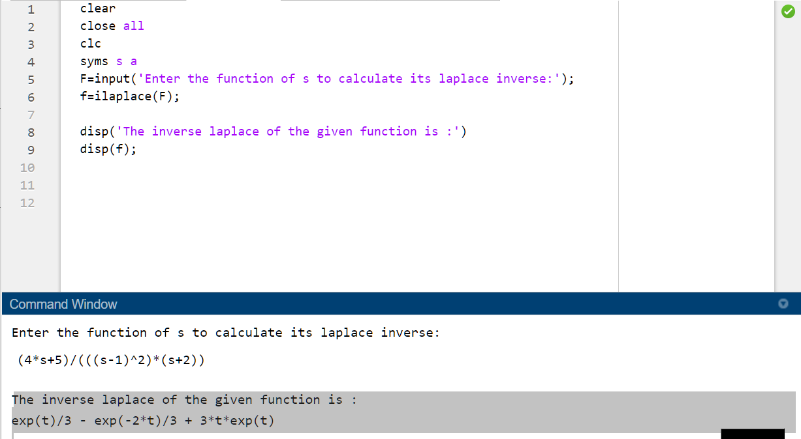

**Question number 2(ii)**

**Find the inverse Laplace transforms of the following functions** 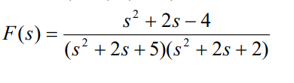

**CODES:**

clear

close all

clc

syms s a

F=input('Enter the function of s to calculate its laplace inverse:');

f=ilaplace(F);

disp('The inverse laplace of the given function is :')

disp(f);

**INPUT:**

Enter the function of s to calculate its laplace inverse:

(s^2+2*s-4)/((s^2+2*s+5)*(s^2+2*s+2))

**OUTPUT:**

The inverse laplace of the given function is :  
(3*sin(2*t)*exp(-t))/2 - 2*exp(-t)*sin(t)

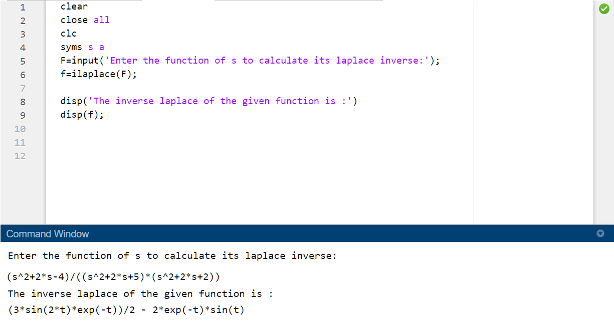

***THANK YOU***